Date | 01/11/2025
Time ID | NM2025TMID06951
Project Name | Laptop Request Catalog Item
Maximum Marks | 4 marks

PROJECT DESIGN PHASE 2

Data Flow Diagram (DFD) – Laptop Request Catalog Item
Level 0 – Context Diagram
Overview:
This diagram illustrates how data moves between external entities and the main Laptop Request System.
External Entities:
- Employee: Submits a new laptop request through the catalog.
- IT Admin: Reviews and approves/rejects requests.
- Procurement Team: Processes approved laptop requests for purchase or allocation.
- Inventory System: Updates available laptop stock after request fulfillment.
Main Process:
- Laptop Request Management System :The central process responsible for handling laptop catalog items, requests, approvals, and inventory updates.
Data Flows:
- From Employee → System: Laptop request details (model, specifications, justification).
- From System → IT Admin: Notification for approval/rejection.
- From IT Admin → System: Decision status update.
- From System → Procurement Team: Approved request details.
- From Procurement Team → Inventory System: Update on fulfilled requests and stock adjustment.

Level 1 – Detailed Data Flow Diagram

Process 1: Laptop Request Submission:
- Input: Laptop request data submitted by employee.
- Output: Request record stored in the database.
- Data Store: Laptop Request Database.
Process 2: Request Approval Workflow:
- Input: Request data from the database.
- Function: IT Admin reviews and approves or rejects the request.
- Output: Approval status and remarks.
- Data Store: Approval Records.
Process 3: Procurement Processing
- Input: Approved requests.
- Function: Forward to procurement team for purchase or allocation from stock.
- Output: Procurement record and update status.
- Data Store: Procurement Database.
Process 4: Inventory Update
- Input: Fulfilled request information.
- Output: Updated stock levels and availability.
- Data Store: Inventory Database.
Process 5: Reporting & Monitoring
- Input: Request, approval, and fulfillment data.
- Function: Generate reports for tracking requests, approvals, and stock levels.
- Output: Dashboards and reports for management.
- Data Store: Reporting Database.

Data store:
- Laptop Request Database
  - Stores all submitted laptop requests and their details.
  - Fields: Request ID, Employee ID, Laptop Model, Specifications, Justification, Date Submitted.
- Approval Records
  - Stores IT admin decisions on laptop requests.
  - Fields: Request ID, Approval Status, Reviewer Name, Remarks, Date Reviewed.
- Procurement Database
  - Holds data on approved requests sent to procurement for processing.
  - Fields: Request ID, Purchase Order Number, Vendor Details, Status, Delivery Date.
- Inventory Database
  - Tracks available laptops and stock levels.
  - Fields: Item ID, Laptop Model, Quantity Available, Location, Status.
- Reporting Database
  - Aggregates data for analytics and performance tracking.
  - Fields: Request Metrics, Approval Rates, Fulfillment Time, Inventory Turnover.

Key Data Flows
- Employee → Laptop Request System
→ Laptop Request Details (Laptop model, specifications, justification, urgency).
- System → Laptop Request Database
→ Stored Request Record (New entry with unique Request ID and timestamp).
- Laptop Request Database → IT Admin
→ Pending Request List (For approval or rejection).
- IT Admin → System
→ Approval Decision (Approved / Rejected status with comments).
- System → Approval Records Database
→ Approval Data Entry (Logs status and reviewer details).

EXAMPLE

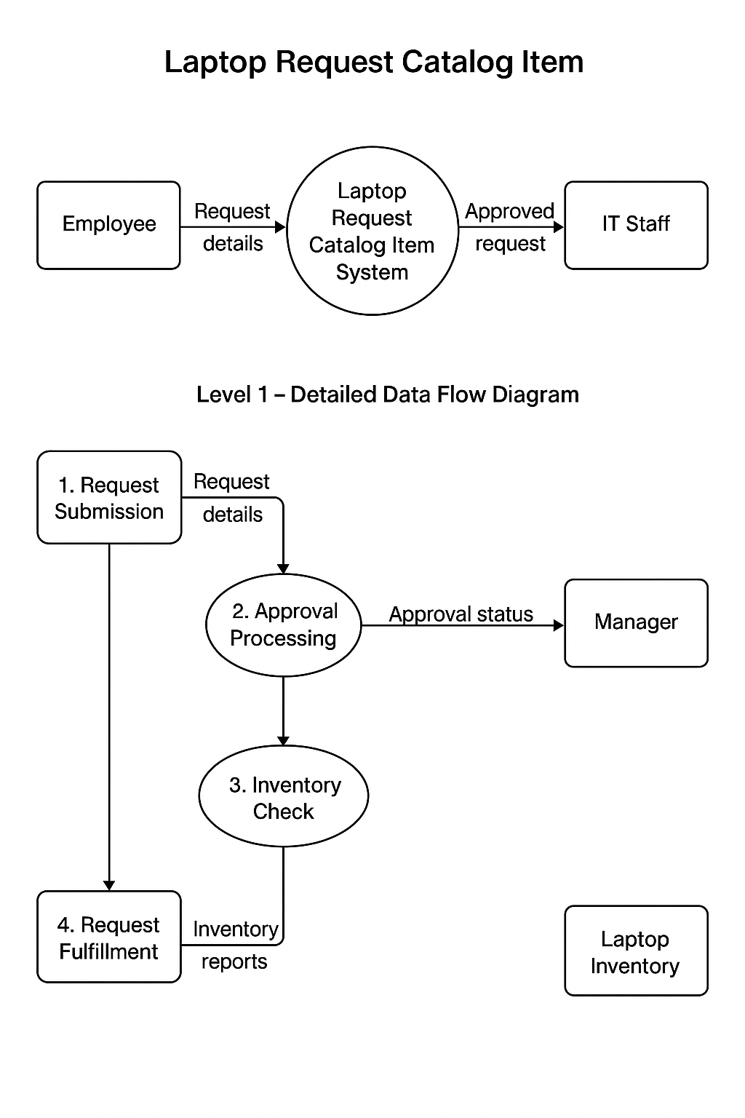

User Stories

- Employee
As an employee, I want to request a laptop from the available catalog, so that I can get the right equipment for my work efficiently.
- IT Admin
As an IT admin, I want to review and approve laptop requests, so that only valid and justified requests are processed.
- Procurement Team Member
As a procurement officer, I want to receive approved requests automatically, so that I can initiate purchasing or allocation without manual follow-ups.
- System Administrator
As a system administrator, I want to maintain catalog items and workflows, so that the system remains updated and aligns with policy changes.
- Management
As a manager, I want to review reports on laptop requests and fulfillment, so that I can ensure efficient resource allocation and budget utilization.

